Functional & Performance Testing Template
Model Performance Test

Date | 03 October 2026
Team ID | SWTID-2026-8647
Project Name | Implement Client Script & UI Policy (Incident)
Maximum Marks

Test Scenarios & Results
Project: Implement Client Script & UI Policy (Incident) – ServiceNow Incident table.
Test Case ID | Scenario (What to test) | Test Steps (How to test) | Expected Result | Actual Result | Pass/Fail
FT-01 | Incident Form – Normal Priority | Open the Incident form and create a normal-priority Incident. Review the fields controlled by the UI Policy. | Normal-priority Incident remains available for standard entry and conditional controls are not unnecessarily applied. | To be verified during implementation | To be verified
FT-02 | High/Critical Priority – UI Policy | Create or update an Incident with the configured high-priority condition and observe the affected fields. | Configured fields become mandatory, visible, or read-only according to the UI Policy Actions. | 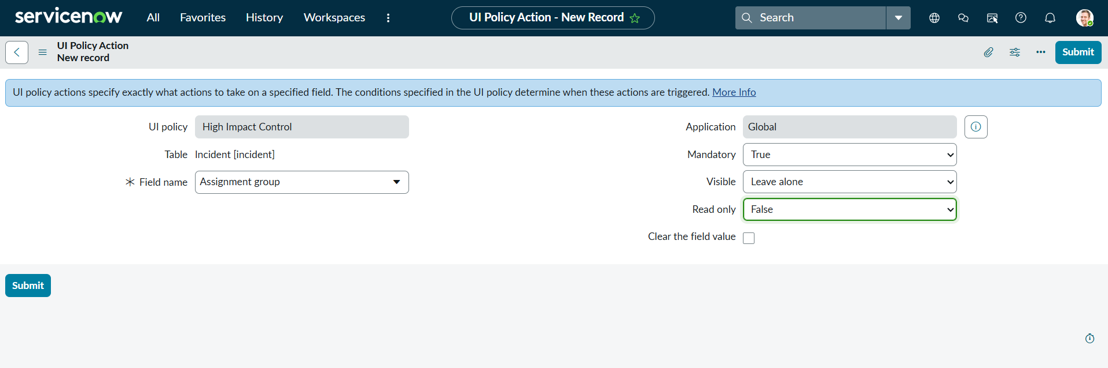  Supplied screenshot evidence | To be verified
FT-03 | Required Field Validation | With the applicable condition active, leave a required field empty and attempt to proceed/submit. | Configured client-side validation should identify missing information and provide appropriate feedback. | 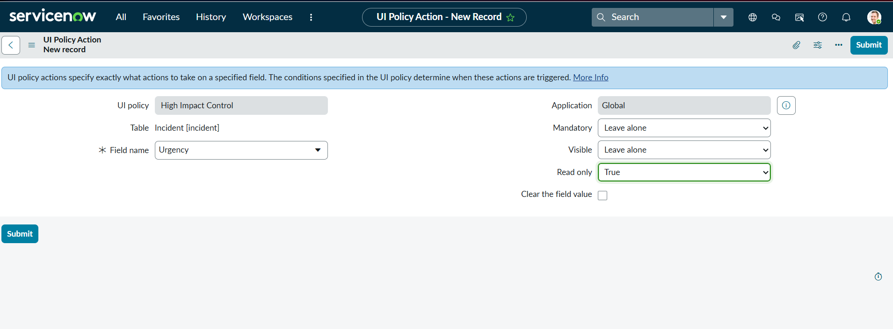  Supplied screenshot evidence | To be verified
FT-04 | Required Information Provided | Enter the required Incident information and proceed with the form. | The Incident should be allowed to proceed when required information is provided. | To be verified during implementation | To be verified
PT-01 | Client Script / Form Response | Change the Incident Impact value to the configured condition and observe the affected form behavior. | Configured client-side behavior should apply the intended Incident form behavior. | 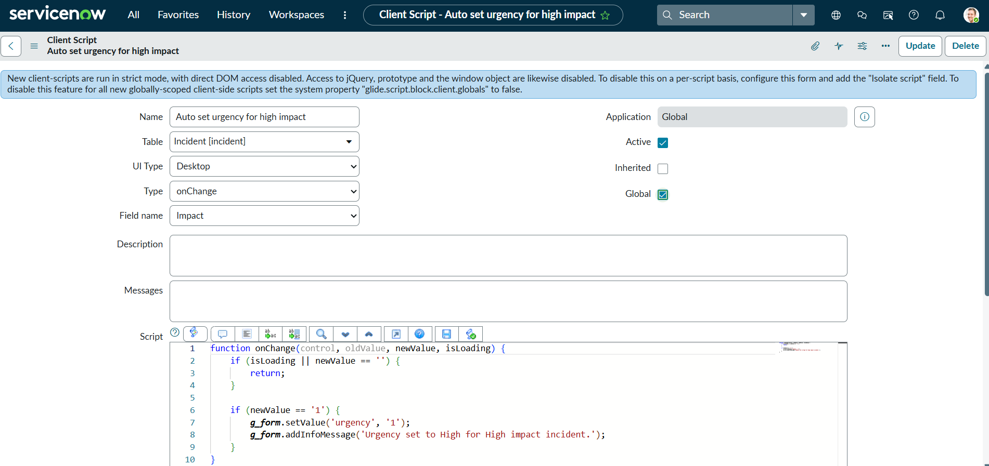  Supplied screenshot evidence | To be verified
PT-02 | List Edit State Control | Attempt to change the configured Incident State through list editing. | The configured control should prevent the restricted state change and direct the user to the Incident form where appropriate. | 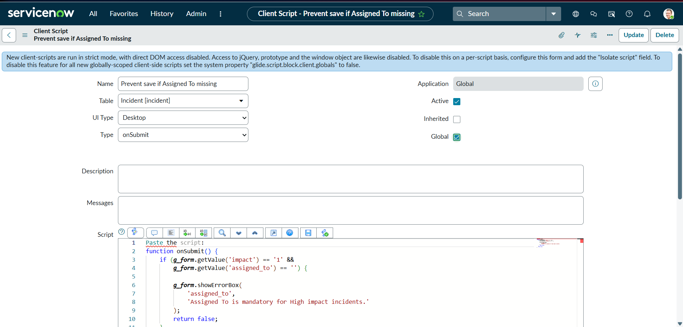  Supplied screenshot evidence | To be verified
PT-03 | Configuration Stability | Review the Incident form under different applicable conditions. | Configured controls should operate consistently without unexpected form behavior. | 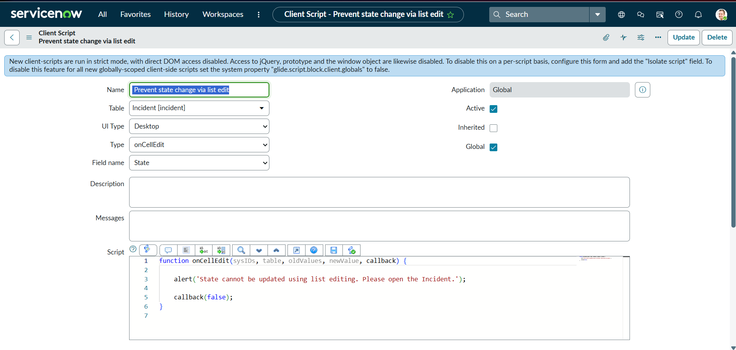  Supplied screenshot evidence | To be verified

